|  |  |  |  |
| --- | --- | --- | --- |
| **New Arrival** | | | |
|  |  |  |  |

|  |  |  |  |
| --- | --- | --- | --- |
| **Trending** | | | |
|  |  |  |  |

**Logo**



**Cart**

**Sign In | Join**



**Promo**

Search



All Category

**Women**

**Accessories**

**Kids**

**Men**

**Contact Us**

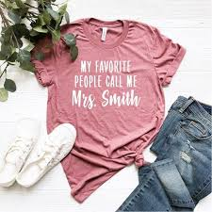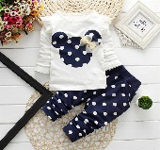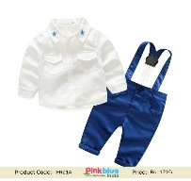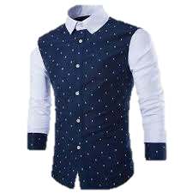

|  |  |  |  |
| --- | --- | --- | --- |
| **ABOUT US** | **WHAT’S IN STORE** | **INFORMATION** | **FOLLOWS** |
| **Sri Lanka’s biggest fashion chain offers a wide range of clothes and accessories for Men, Women and Kids.** | **Women**  **Men**  **Kids**  **Accessories** | **About Us**  **Promo**  **Contact Us**  **Store Locators** |  |

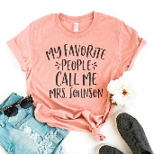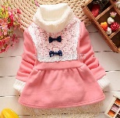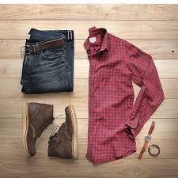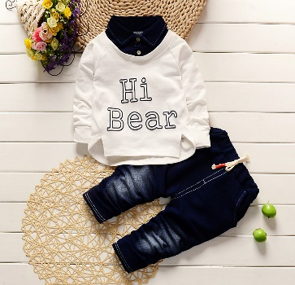



**Logo**



**Cart**

**Sign In | Join**



**Promo**

Search



All Category

**Women**

**Accessories**

**Kids**

**Men**

**Contact Us**

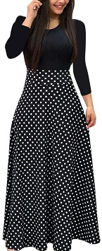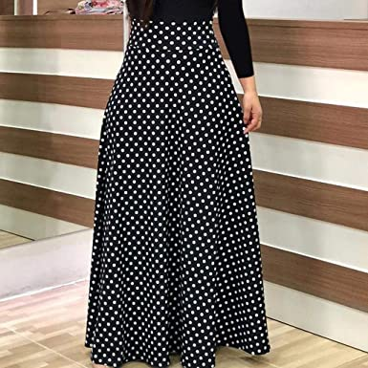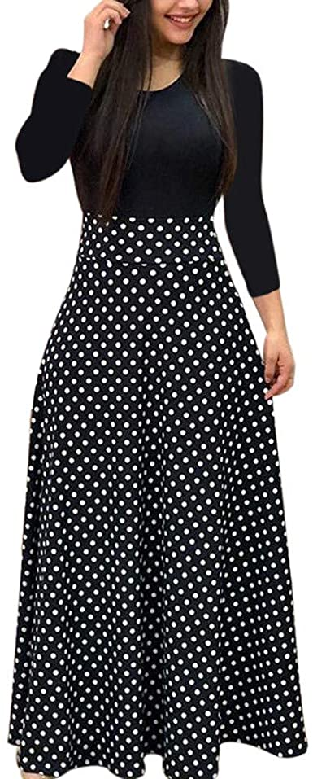

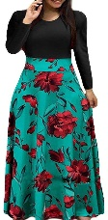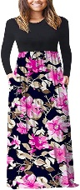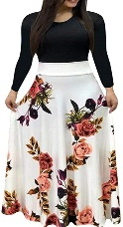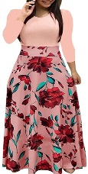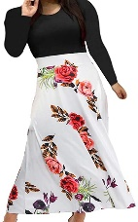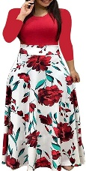

**Color :**

**Size:**

**S**

**M**

**L**

**XL**

**XXL**

**Quantity :**

**1**

**Buy Now**

**Add to Cart**

**Women’s Casual Wear**

LKR.**1,990.00**

SKU: WFD0004

|  |  |  |
| --- | --- | --- |
|  |  |  |
|  |

Sleeve: Full Sleeve

Material: Georgette

Texture: Plain / Tie Up

*Product color may change slightly vary due to photographic lighting.

[**DESCRIPTION**](https://www.nolimit.lk/product/womens-formal-dress-4/#tab-description)

[**REVIEWS (0)**](https://www.nolimit.lk/product/womens-formal-dress-4/#tab-reviews)

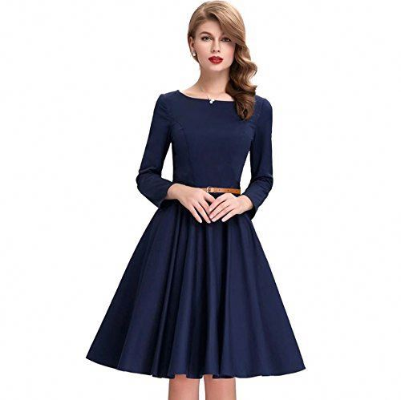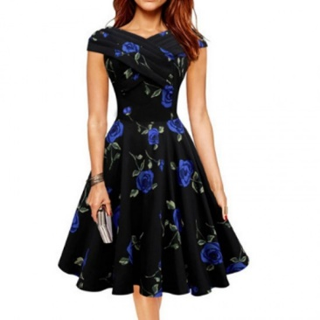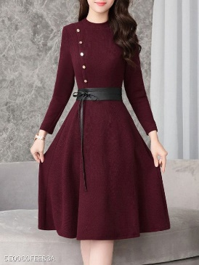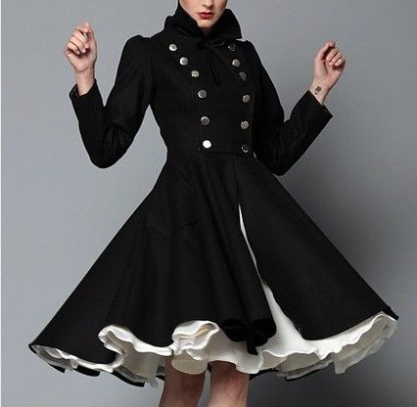

|  |  |  |  |
| --- | --- | --- | --- |
| **ABOUT US** | **WHAT’S IN STORE** | **INFORMATION** | **FOLLOWS** |
| **Sri Lanka’s biggest fashion chain offers a wide range of clothes and accessories for Men, Women and Kids.** | **Women**  **Men**  **Kids**  **Accessories** | **About Us**  **Promo**  **Contact Us**  **Store Locators** |  |

